🏗️ Overall Architecture
Flow of Data:
- Frontend (Next.js + Tailwind + Mapbox) → Renders UI, calls backend APIs.
- Backend (Express.js on Node.js) → Provides REST/GraphQL APIs, handles auth, business logic.
- Database (PostgreSQL) → Stores restaurant data, promotions, filters.
- Search (Elasticsearch) → Indexes restaurant data for fast filtering (street, food type, halal, buffet).
- OpenStreetMap API → Provides geolocation + distance calculations.
- Mapbox → Displays maps and walkable distances visually.
- Passport.js → Handles authentication (social login).
- Plausible Analytics → Tracks usage.
- Docker + GitHub Actions → Deployment pipeline.
Architecture Decision: For Phase 1, keep Next.js and Express as separate apps:
- ✅ Clear separation of concerns (frontend vs backend).
- ✅ Easier scaling later.
- ✅ Cleaner folder structure. Alternative (Next.js API routes) is simpler but limits backend flexibility. Since you’ll need Elasticsearch, Passport, and PostgreSQL, separate backend is better.
📂 Recommended Project Structure
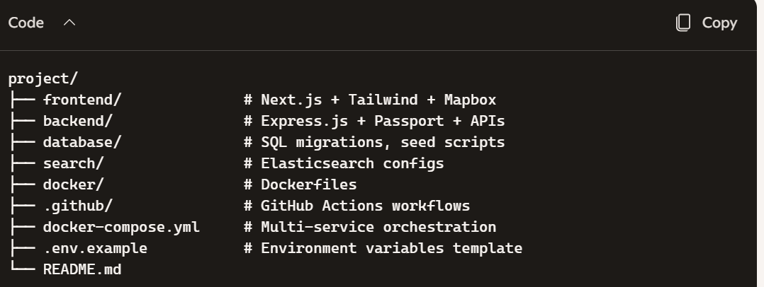

📆 Implementation Roadmap (Milestones)

Phase 1A — Project Initialization
Tasks:
- Create root folder and Git repo.
- Initialize frontend (Next.js).
- Initialize backend (Express).
- Add .env.example.
Commands:
mkdir project && cd project
git init
npx create-next-app@latest frontend
mkdir backend && cd backend && npm init -y
npm install express cors dotenv
Expected Result: Two apps (frontend/, backend/) with basic startup scripts.
Verify: Run npm run dev in frontend → see Next.js starter page. Run node backend/index.js → see “API running” message.

Phase 1B — Frontend (Next.js + Tailwind)
Tasks:
- Install Tailwind CSS.
- Configure responsive layout.
- Create restaurant listing page.
Commands:
cd frontend
npm install -D tailwindcss postcss autoprefixer
npx tailwindcss init -p

Files: tailwind.config.js → add ./pages/**/*.{js,ts,jsx,tsx}. globals.css → include Tailwind base, components, utilities.
Verify: Add a styled button → confirm Tailwind works.

Phase 1C — Backend API (Express)
Tasks:
- Create REST API endpoints (/restaurants, /filters).
- Enable CORS for frontend.
Code Example (backend/index.js):
const express = require('express');
const cors = require('cors');
require('dotenv').config();

const app = express();
app.use(cors());
app.use(express.json());

app.get('/restaurants', (req, res) => {
res.json([{ name: "Test Restaurant", halal: true }]);
});

app.listen(4000, () => console.log("API running on port 4000"));

Verify: Visit http://localhost:4000/restaurants → JSON response.

Phase 1D — PostgreSQL
Tasks:
- Install PostgreSQL locally or via Docker.
- Create restaurants table.
Commands:
docker run --name pg -e POSTGRES_PASSWORD=secret -p 5432:5432 -d postgres
npm install pg

Schema Example (database/schema.sql):
CREATE TABLE restaurants (
id SERIAL PRIMARY KEY,
name VARCHAR(100),
food_type VARCHAR(50),
halal BOOLEAN,
buffet BOOLEAN,
new_shop BOOLEAN,
latitude FLOAT,
longitude FLOAT
);
Verify: Insert sample rows → query with psql.

Phase 1E — Maps (OpenStreetMap + Mapbox)
- Use OpenStreetMap API for distance calculation.
- Use Mapbox GL JS in frontend for map rendering.
Frontend Example:
import mapboxgl from 'mapbox-gl';
mapboxgl.accessToken = process.env.NEXT_PUBLIC_MAPBOX_TOKEN;
Verify: Map renders with markers for restaurants.

Additional:
pls local run
cd frontend
npm install
npm run dev
and open http://localhost:3000/map

Phase 1F — Search & Filtering (Elasticsearch)
- Install Elasticsearch via Docker.
- Index restaurant data.
- Query by filters.
Commands:
docker run -d -p 9200:9200 -e "discovery.type=single-node" elasticsearch:8.12.0
npm install @elastic/elasticsearch
Verify: curl localhost:9200/_cat/indices → see index.

Phase 1G — Authentication (Passport.js)
- Add Google OAuth strategy.
- Protect API routes.
Code Example:
const passport = require('passport');
const GoogleStrategy = require('passport-google-oauth20').Strategy;
passport.use(new GoogleStrategy({
clientID: process.env.GOOGLE_CLIENT_ID,
clientSecret: process.env.GOOGLE_CLIENT_SECRET,
callbackURL: "/auth/google/callback"
}, (token, refresh, profile, done) => done(null, profile)));

Phase 1H — Analytics (Plausible)
- Add script in Next.js _app.js.
<script async defer data-domain="yourdomain.com" src="https://plausible.io/js/script.js"></script>

Phase 1I — Docker
- Create Dockerfiles for frontend & backend.
- Use docker-compose.yml to orchestrate services.

Phase 1J — GitHub Actions (CI/CD)
- Add .github/workflows/deploy.yml.
- Build + test + deploy pipeline.

Phase 1K — Security & Testing
- HTTPS via Let’s Encrypt.
- Input validation.
- Unit tests with Jest.

Phase 1L — Deployment
- Deploy to VPS or cloud (e.g., DigitalOcean, AWS).
- Run containers with Docker Compose.

✅ Phase 1 Definition of Done Checklist
- [ ] Frontend renders restaurant list with filters.
- [ ] Backend API serves restaurant data.
- [ ] PostgreSQL stores restaurant info.
- [ ] Elasticsearch enables fast filtering.
- [ ] Mapbox shows restaurants on map.
- [ ] OpenStreetMap calculates walkable distance.
- [ ] Authentication works with Passport.js.
- [ ] Analytics integrated via Plausible.
- [ ] Dockerized services run locally.
- [ ] CI/CD pipeline builds and deploys.
- [ ] Basic security (HTTPS, input validation).
👉 Step 1 for you: Phase 1A — Project Initialization. Would you like me to now walk you through the exact commands and files for Step 1A so you can set up the repo and initialize both frontend and backend?

